Sign Language Companion

According to Census 2011 in India, around 7 million people are differently abled in Hearing and Speaking, of which around 15% are children. Only a handful of sign language schools are presently working to cater the needs of this demographic of population. This path of career in India is only followed by those who are either directly affected by or who wish to serve such a task.

The idea is to maximise the reach and availability of a teacher by acting as a companion to students in learning communication skills.

The purpose of the application is to teach sign language through camera by interacting in real time without using internet for offline accessibility and privacy.

The sign language taken into consideration is Indian Sign Language from Indian Sign Language Research and Training Center.

Source
- https://www.bbc.com/news/world-asia-india-39101899
- https://enabled.in/wp/disabled-population-in-india-as-per-census-2011-2016-updated/

Problem Statement
There is standardized language in America for deaf and mute known as ASL(American Sign Language) from 1960’s whereas in India the concept of single sign language is not possible. There is so much diversity in language that sign language can’t be made as a single standard. So there are various types of sign language under ISL -
- Bangalore-Madras Sign Language
- Bombay Sign Language
- Calcutta Sign Language
- Delhi Sign Language
A person is taught 2 dialects - sign Language and spoken language. The symbols are not hugely different, they can be mapped to a given dictionary in any spoken language. We will keep hindi language in our problem statement to generate the conversations.
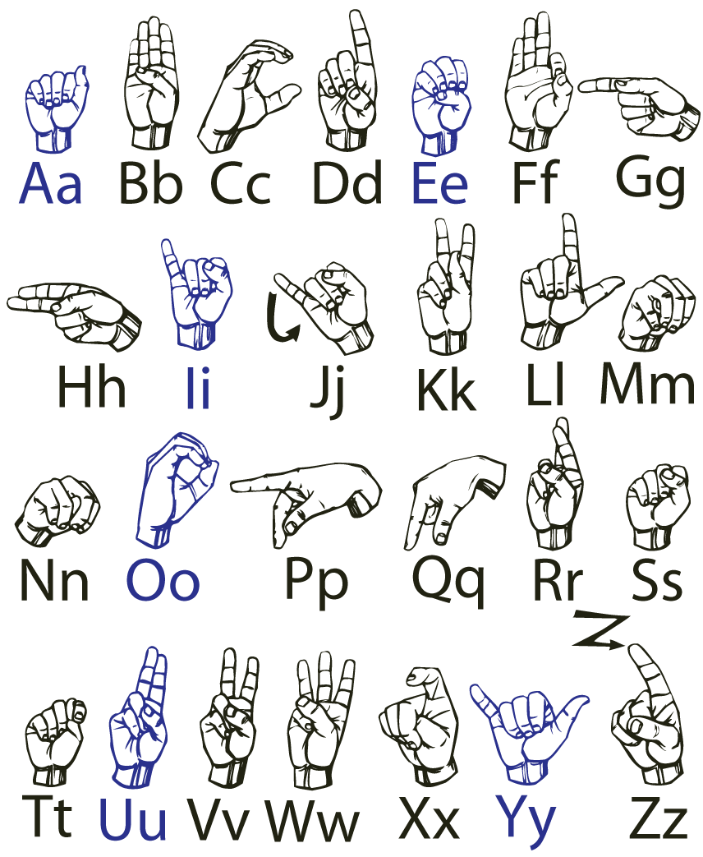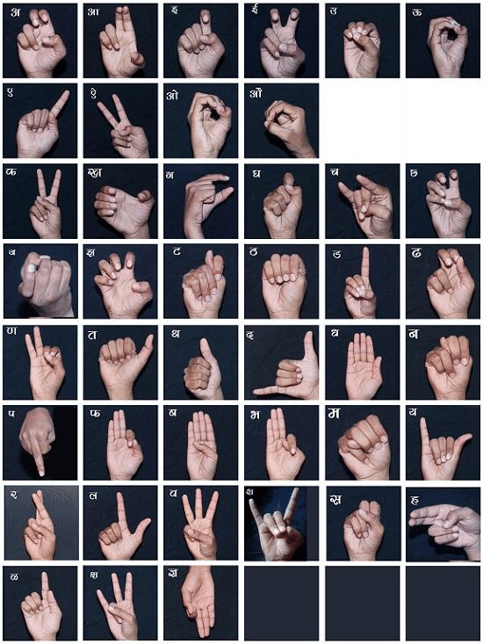

The focus is on below tasks -

Letter - Recognize the language symbols
Word - Formulate words from letters
Action - To map a particular gesture with a certain word or activity
Analyze - To analyze the sign language and convert to English/Hindi

Plan

Use cases
The project should cover the following functional requirements
- The app comprises of modules containing specific exercises that are required in daily life in interaction.
- Letter and symbol recognition using hand gestures.
- Word recognition using series of particular symbols of hand pose.
- Facial expression recognition for communication.
- Intent recognition and generation after the completion of individual tasks.
- Real-time feedback of the given task using interactive UI and rectifying particular mistakes.
- To generate a reply on the task given using AR
- Gamification of tasks as a part of the learning process by giving incentives on completion

Project Modules

S.No. | Module | Description
1. | Task Selector | To list all the subject modules for the application
2. | Hand/Pose Detection | To detect pose points of hand and person
3. | Symbol Recognition | To recognize letters and words using results from detection module
4. | Face Analyzer | To measure the apt expression
5. | Intent builder | To formulate the scenario from the ensemble of features
6. | Task Analyzer | For a given task, evaluate the precision of gestures and give feedback
7. | Interactor | To generate a reply in the form of 3D avatar/Voice/Text
8. | Scoreboard | To rate the user based on the skill

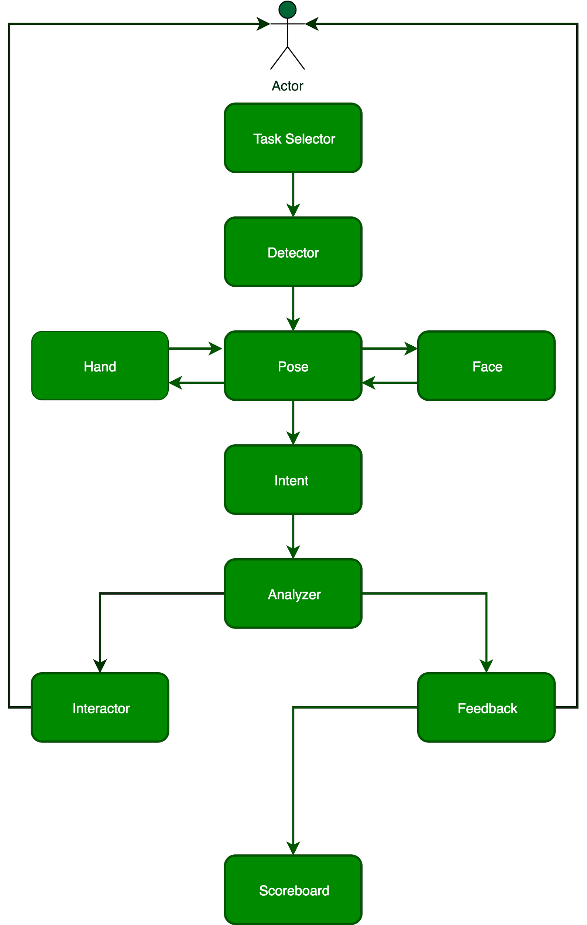
Flow diagram for the modules in the application

Technology Stack
- Tensorflow Lite
  - Recognizer Module
    - Hand Gesture recognition using Openpose
    - Hand Gesture classification
    - Face classification for expressions
  - Task Analyzer
    - Intent formulation using features over a series of frames.
  - Speech to Text / Text to Speech
    - Using Google’s Wavenet model.
- AR Core
  - Recognize the scenes and embedding required gestures of hand.
- MediaPipe Framework
  - Orchestrate the modules for each frame.

Current Progress
- Mediapipe framework for the modules for hand detection, palm detection and landmark detection used from following model - Model Card
- Used the gesture recognition by rules based approach.
- Sign language dataset curation using Youtube videos
- Functionality of openpose module checked.

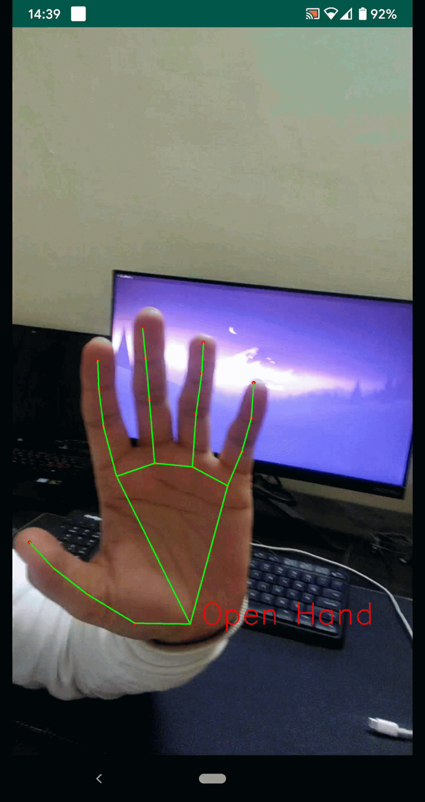 SAMPLE

Project Timeline
Timeline Sheet
Phase | Start | Tent. End | Story | Task | Remarks
Analysis | December 1, 2019 | December 29, 2019 | Data formulation and Analysis | Sources  Cleanup and Preparation  Annotation  Collection Format | Indian Sign Language Research and Training Center videos,  Task module videos
Research | December 1, 2019 | December 8, 2019 | Hand Module | Landmark Detection | Mediapipe
Research | December 1, 2019 | December 15, 2019 | Body Module | Pose Detection - Upper Body | Openpose
Research | December 1, 2019 | December 22, 2019 | Face Module | Detection - Eye position  Expression | Mediapipe - https://sites.google.com/view/perception-cv4arvr/mediapipe
Research | December 1, 2019 | December 29, 2019 | Sequence Module | Curation of all features | LSTM from CNN
Development | January 1, 2020 | January 31, 2020 | Training | Hand  Body  Face  Sequence classification | All in one task vs Multi module approach
Research | January 1, 2020 | January 12, 2020 | Conversion to mediapipe | Tflite conversion
Development | January 1, 2020 | January 31, 2020 | Framework development | Mediapipe
Development | January 1, 2020 | January 31, 2020 | Avatar mechanism | Overlay build  Predefined action
Design | January 1, 2020 | January 31, 2020 | Avatar mechanism | Define the body part
Design | January 1, 2020 | January 31, 2020 | Flow of application | Activity Flow  Design of each activity
Development | January 1, 2020 | TBD | MVP | Mediapipe integration  Android flow test | Minimal flow in working condition
Testing | January 1, 2020 | TBD | Bug Fixes
Testing | January 1, 2020 | TBD | Beta Testing | Feedback mechanism

Challenges
- Robust models for widespread application over different age group, ethnicity and sex
- Battery life optimization
- Heavily pruned models for the tasks
- Integration over the pipeline to handle multiple tasks
- Minimal design to avoid confusion
- Deaf and Mute school collaboration for good feedback
- Machines for training the models

Team

ML - Prince Patel. Working as a Machine Learning Engineer in UncannyVision for 4 years.
https://princep.github.io/
Android - Aman Arora. Working as an Android Developer in Meesho for 4 years.
https://github.com/amanarora12
Designer - Aditya Narayan. Working as a Designer in involvio for 4 years.
https://dribbble.com/crabsbeard

Next steps.

- The final step is to fill out this form to officially submit your proposal.

